Our Clothes

Clothes are the things that people wear to cover their bodies such as shirts, pants, dresses, and coats etc.
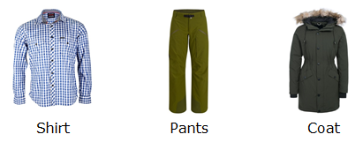

It protects us from heat, cold, rain and wind.
It also protects us from insect bites.

People of different region wear different clothes.
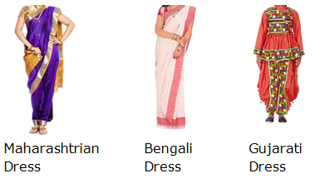
We should keep our clothes clean and keep them neat.

In summer we prefer to wear cotton clothes as it keeps us cool.

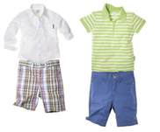
In winter we wear woolen clothes as it keeps us warm.
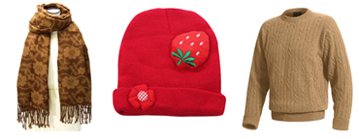
We use umbrella or wear raincoat when we go out in rain.
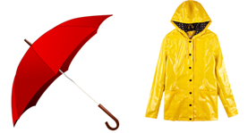

We wear standard set of clothing when we go to school. This is called school uniform. Different schools have different school uniform. My best friend Ravi goes to different school. So, his uniform is different from ours.
